DSA Assignment-1
Q1. Define Data Structures and explain their importance in problem-solving and programming efficiency.
Answer: A data structure is a way of organizing and storing data in a computer so that it can be used efficiently. Different types of data structures are used depending on the requirements of a problem. Some common data structures are arrays, linked lists, stacks, queues, trees, and graphs.
Data structures are important because they help in managing data efficiently. They make searching, sorting, inserting, and deleting data easier and faster. By using the right data structure, we can reduce the execution time of a program and use memory more effectively. Therefore, data structures play an important role in problem-solving and software development.

Q2. Write a C++ program to input 10 integers into an array and display the sum, average, maximum, and minimum values.
Answer:
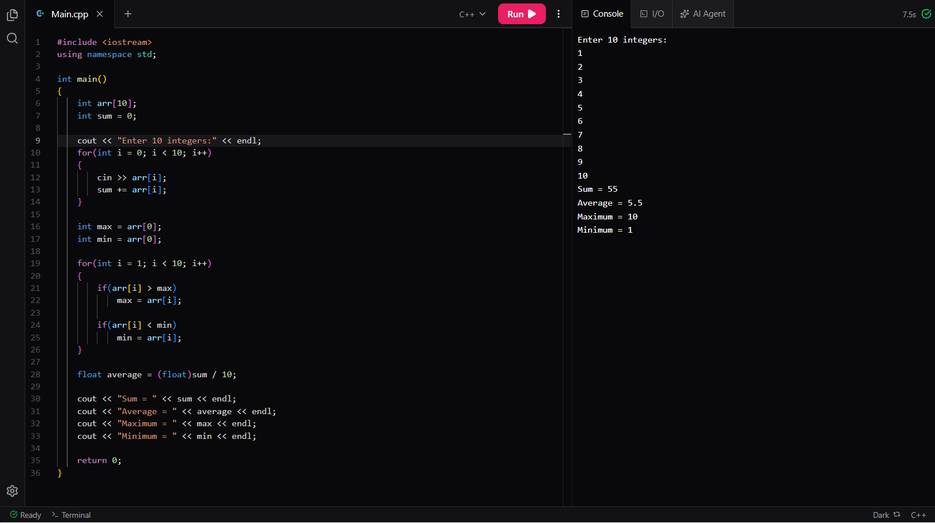
Q3. Explain Big-O notation. Determine the time complexity of a single loop and a nested loop with suitable C++ examples.
Answer: Big-O notation is used to describe the performance of an algorithm. It tells us how the running time of a program changes when the input size increases. It helps us compare different algorithms and choose the most efficient one.
Example of Single Loop:
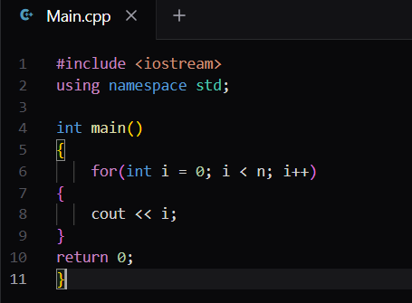
In this loop, the statement executes n times.
Time Complexity = O(n)
Example of Nested Loop:
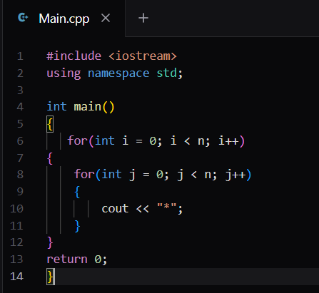
Here, the inner loop runs n times for each iteration of the outer loop.
Total operations = n × n = n²
Time Complexity = O(n²)
Thus, a single loop has linear complexity O(n), while a nested loop has quadratic complexity O(n²).

Q4. What is an array? Explain its advantages and limitations compared to other data structures.
Answer: An array is a collection of elements of the same data type stored in consecutive memory locations. Each element can be accessed using an index.
Example:
int arr[5] = {10, 20, 30, 40, 50};
Advantages of Arrays:
- Easy to understand and use.
- Elements can be accessed directly using an index.
- Faster access to data.
- Requires less memory compared to some other data structures.
Limitations of Arrays:
- The size of an array is fixed.
- Insertion and deletion operations are difficult.
- Memory may be wasted if the array size is larger than required.
- Only similar data types can be stored.
Compared to linked lists, arrays provide faster access to elements, but linked lists are more flexible because their size can change dynamically.

Q5. Write a C++ program to perform linear search on an array and explain its time complexity.
Answer:
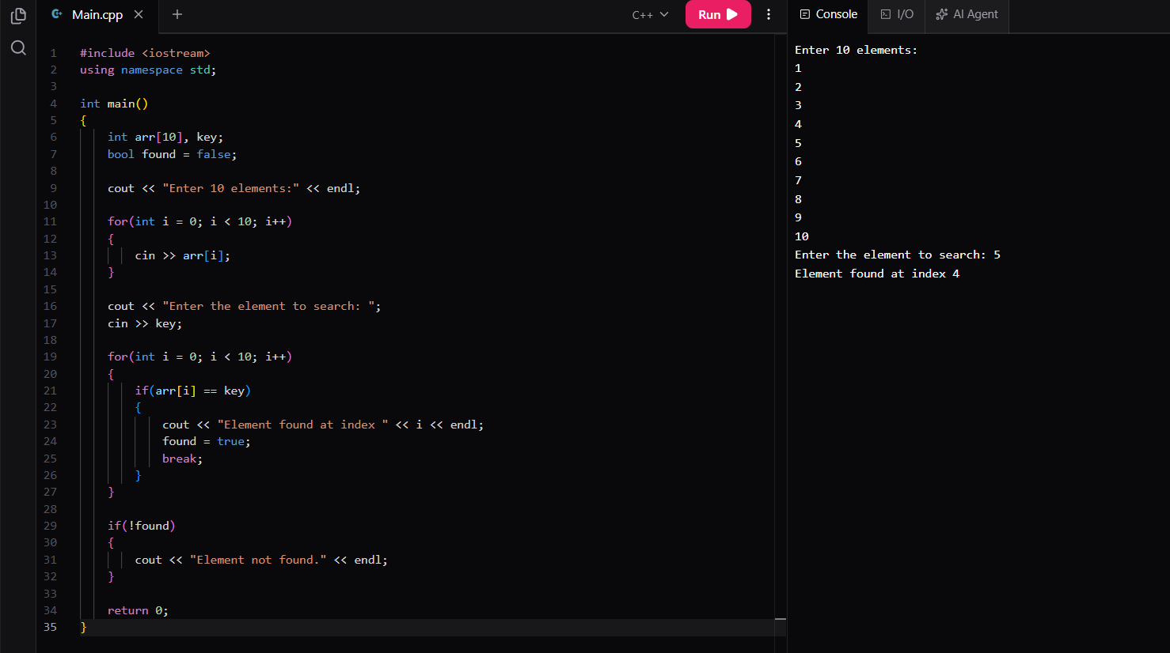

Time Complexity
Linear search checks each element one by one until the required element is found.
- Best Case: O(1) (element found at the first position)
- Average Case: O(n)
- Worst Case: O(n) (element found at the last position or not found)
Therefore, the overall time complexity of linear search is O(n).

